**Java SE Project**

YumXpress Application

***ViewDeliveryStaffFrame Documentation***

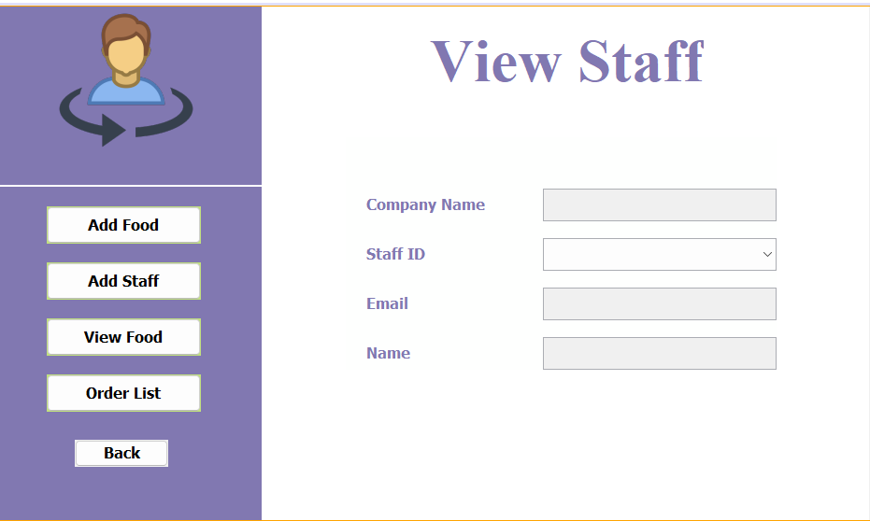

**2. STEPS TO BE DONE IN ViewDeliveryStaffFrame**

In the **ViewDeliveryStaffFrame** we need to do following steps:

1. **Adding a method called getAllStaffIdByCompanyId() in the StaffDAO class This method will accept a companyId as argument and return Id of all the Staff members of that company as List.**
2. **Add a method called getStaffDetailsById() in the StaffDAO class This method will accept a staffId as argument and return complete details of that Staff member.**
3. **Show all the staff id in the JComboBox as soon as the ViewDeliveryStaffFrame loads**
4. **Also show the name and email of the selected staff on the Frame by setting event handler for JComboBox**

**Coding of getAllStaffIdByCompanyId() method in StaffDAO:**

**public static List<String> getStaffIds(String companyId) throws SQLException {**

**Connection conn = DBConnection.getConnection();**

**PreparedStatement query = conn.prepareStatement("select staff_id from staffs where company_id=?");**

**query.setString(1, companyId);**

**ResultSet executeQuery = query.executeQuery();**

**List<String> staffList = new ArrayList<>();**

**while (executeQuery.next()) {**

**staffList.add(executeQuery.getString("staff_id"));**

**}**

**return staffList;**

**}**

**Coding for getStaffDetailsById() method in StaffDAO class :**

**public static StaffPojo getStaffDetailsById(String staffId) throws SQLException {**

**Connection conn = DBConnection.getConnection();**

**String qry = "SELECT staff_id,email_id, staff_name FROM Staff WHERE staff_id = ?";**

**PreparedStatement query = conn.prepareStatement(qry);**

**query.setString(1, staffId);**

**ResultSet result = query.executeQuery();**

**result.next();**

**StaffPojo staff = new StaffPojo();**

**staff.setStaffId(staffId);**

**staff.setEmailId(result.getString("email_id"));**

**staff.setStaffName(result.getString("staff_name"));**

**return staff;**

**}**

**. Coding for ViewDeliveryStaffFrame Constructor :**

**public class ViewDeliveryStaffFrame extends javax.swing.JFrame {**

**private JFrame showFrame;**

**private List<String> staffIdList;**

**public ViewDeliveryStaffFrame() {**

**initComponents();**

**this.setLocationRelativeTo(null);**

**lblOwnerProfile.setText("@" + OwnerProfile.getOwnerName());**

**loadAllStaffId();**

**}**

**Coding for loadAllStaffId() method :**

**private void loadAllStaffId() {**

**try {**

**staffIdList = StaffDAO.getAllStaffIdByCompanyId(OwnerProfile.getCompanyId());**

**for (String staffId : staffIdList) {**

**jcStaffIds.addItem(staffId);**

**}**

**} catch (SQLException ex) {**

**ex.printStackTrace();**

**}**

**}**

**Coding for actionPerformed() of JComboBox() method :**

**private void jcStaffIdsActionPerformed(java.awt.event.ActionEvent evt) {**

**String staffId = jcStaffIds.getSelectedItem().toString();**

**try {**

**StaffPojo staff = StaffDAO.getStaffDetailsById(staffId);**

**txtCompanyName.setText(OwnerProfile.getCompanyName());**

**txtEmailId.setText(staff.getEmailId());**

**txtName.setText(staff.getStaffName());**

**} catch (SQLException ex) {**

**ex.printStackTrace();**

**}**

**}**